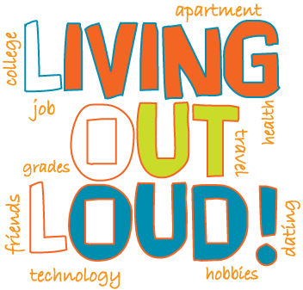
“Living Out Loud” (LOL)
Goal Setting Workshop

Supporting students with disabilities

to BOLDLY live out their goals!

Here are the facts…
- Special education students are more than twice as likely as their peers in general education to drop out of high school.
- Youth with disabilities are half as likely as their peers without disabilities to participate in postsecondary education.
- Current special education students can expect to face much higher adult unemployment rates than their peers without disabilities.
- Young adults with disabilities are three times likelier to live in poverty as adults than their peers without disabilities.

What is “Living Out Loud?”
“Living Out Loud” is a goal setting workshop that KYEA is bringing right into the school classroom! LOL is not just a title; it is a motto to take control of one’s life and be the author of our own future. This message will be brought directly to your students when they experience the LOL workshop. The students will learn how to set realistic, measurable goals; what resources are available to them in reaching these goals; will be encouraged to have high expectations and think big; will hear first-hand stories of youth with disabilities who have reached their goals; and will create a self-authored plan with short and long term goals in various life domains.

KYEA will provide…
- Two, one-hour long sessions directly in your classroom. The first session will be a presentation on goal setting. The second session will consist of KYEA staff working with your students on their Individual Empowerment Plan.
- Handouts, helpful tips, interactive activities, and personal stories to make goal setting fun and empowering for your students.
- The actual Individual Empowerment Plan (IEP)- not to be confused with a school IEP. Our IEP covers various areas of life and can provide good practice for creating the school IEP.
- One-on-one interaction and support to your students while they are writing goals for their Empowerment Plan.
- Ideas for resources, mentors, assistive technology, and other contacts that can help the students reach their goals. Also, we will get them thinking about how their disability affects their goals.
- Follow up and support to your students even after the LOL sessions. We will stay in contact with them and encourage them to accomplish their goals!

How will this help you… the TEACHER?
- You’ve tried to teach your students about the real world, but are they really listening? We will encourage your students and help them prepare in a very real, honest way.
- We know you are short on time. Let us take the time to work with your students on their goals. This lessons your load and allows us to do what we love!
- We have lots of contacts and can expose your students to various role models.
- We know the resources! Let us bring them to your students. This cuts down on your research time.
- We can help with the IEP process! LOL will emphasize the importance of setting goals and will explain the purpose of an IEP. This provides the foundation for you and your student to work more effectively on their school IEP.

Bring LOL to your school!
To schedule a free workshop, contact Carrie at 785.215.6655 or carrieg@kyea.org.

